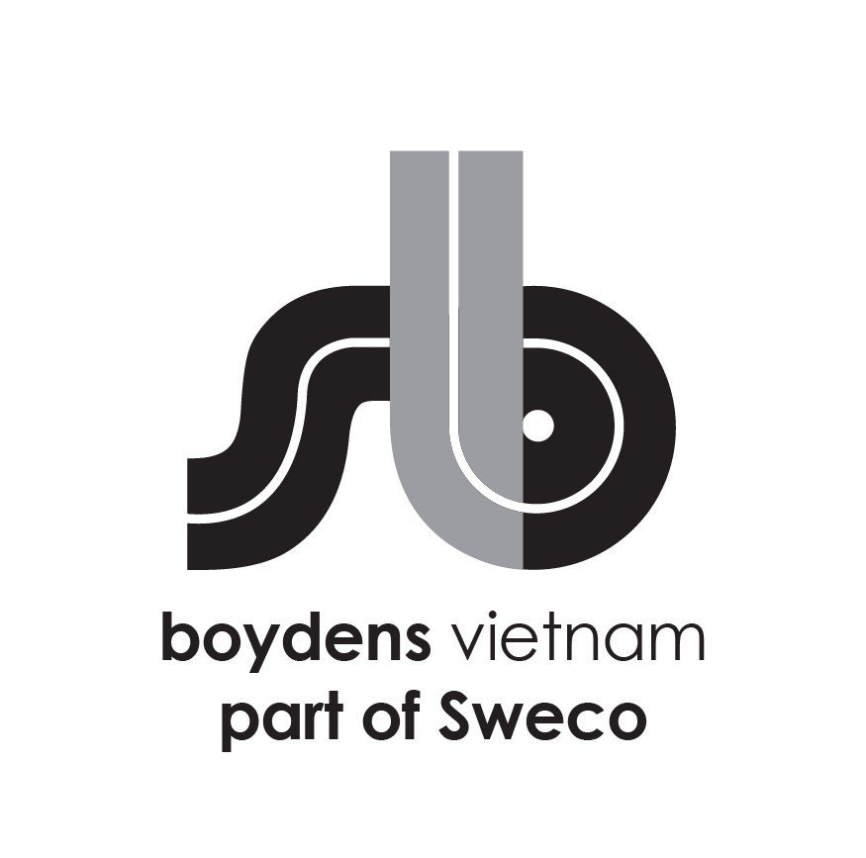

**Job Description:**

|  |  |
| --- | --- |
| Department | BIM and Architecture |
| Position | **Architect Revit Modeler (International Projects)** |
| Work Location | Hanoi |
| Direct Manager | BIM Manager/ Operation Manager |

Boydens Vietnam part of Sweco (Sweco Vietnam) is a branch of, and 100% FDI owned by Sweco Belgium, a member of Sweco Group, Europe’s leading engineering & architectural consultancy company.

For Industry, Energy, and Infrastructure projects, please visit our website at www.swecogroup.com

For Building sector and local projects, please visit our website at [www.boydensvn.com](https://www.boydens/)

At Sweco Vietnam, we are passionate about transforming society and shaping the future. By collaborating with our clients and leveraging the collective knowledge of our team of over 20,000 motivated engineers and specialists, we co-create innovative solutions that address urbanization, harness the potential of digitalization, and foster sustainability in our societies. If you are eager to be part of this transformative journey, Sweco Vietnam is the ideal employer for you.

1. **Duties and Responsibilities:**

* Work with the dedicated team **on international (mostly European) projects** in an efficient and time-conscious manner on BIM modeling,
* Building Revit Models of Architecture equal to LOD 200 – 300
* Preparing the production of drawings, technical drawings, details, sections, etc. primarily in REVIT
* Manage Room, Space, and drawing sets in a Revit model,
* Provide CAD drafting/BIM modeling and design support,
* Coordinate and manage Revit models,
* Revised drawings to model update implementation,
* Create Revit families and CAD blocks in Revit if needed,
* Other duties will be assigned by the Project Manager or BIM Manager

1. **Requirements**

* 2-4 years of post-graduate experience in Architecture, Civil Engineer filed
* Good Ability to read/interpret ARC concept drawings
* Good Revit skills
* Experience in multidisciplinary coordination is a plus
* Experience in offshore projects will be an advantage
* Strong Revit skills in building Revit families are a plus
* Well understand the methodology of building architectural elements
* Knowledge of BIM 360/ACC will be an advantage
* Deep understanding of LOD and LOI levels is a plus
* A deep understanding of BIM is a plus
* Able to communicate (read and write) in English
* Great teamwork skills.

1. **We offer**

* Opportunity to work on forward-thinking projects/overseas projects using the most advanced tools and international standards
* International working environment and European management style
* Competitive salary according to personal experience and ability
* Training opportunities to develop your career
* 15 days annual leave, 12 days sick leave, 15-20 days child sick leave
* International private hospitalization insurance with an annual health check at Vinmec (VIP package)
* 5 working days per week (Mon to Fri) with flexible starting times (7AM-9AM).

1. **Starting date: ASAP**

Interested candidates should send their detailed CVs in English to  [trinhtn@boydensvn.com](mailto:%20trinhtn@boydensvn.com) - Phone/Zalo 0938 308 550

All applications will be kept strictly confidential and only those who are under consideration will be contacted.

**SCOPE OF WORK**

**PHẠM VI CÔNG VIỆC**

* Work with the dedicated team on international (mostly European) projects in an efficient and time-conscious manner on BIM modeling.

*Hợp tác với đội ngũ chuyên nghiệp trong các dự án quốc tế (chủ yếu là các dự án ở Châu Âu) một cách hiệu quả và tiết kiệm thời gian trong việc mô hình hóa BIM,*

* Building Revit Models of Architecture equal to LOD 200 – 300

*Xây dựng mô hình Revit của Kiến trúc đạt chuẩn LOD 200 - 300,*

* Preparing the production of drawings, technical drawings, details, sections, etc. primarily in REVIT

*Chuẩn bị bản vẽ, bản vẽ kỹ thuật, bản vẽ chi tiết, các phần, v.v. chủ yếu trên nền tảng REVIT,*

* Manage Room, Space, and drawing sets in a Revit model,

*Quản lý phòng, không gian và các bộ bản vẽ trong mô hình*

* Provide CAD drafting/BIM modeling and design support,

*Cung cấp bản vẽ CAD/ mô hình BIM và hỗ trợ thiết kế*

* Coordinate and manage Revit models,

*Điều phối và quản lý mô hình Revit*

* Revised drawings to model update implementation,

*Điều chỉnh bản vẽ để cập nhật mô hình*

* Create Revit families and CAD blocks in Revit if needed,

*Tạo Revit families và CAD block trên Revit khi cần*

* Other duties will be assigned by the Project Manager or BIM Manager

*Các nhiệm vụ khác theo yêu cầu từ Quản Lý Dự Án hoặc Quản Lý BIM*