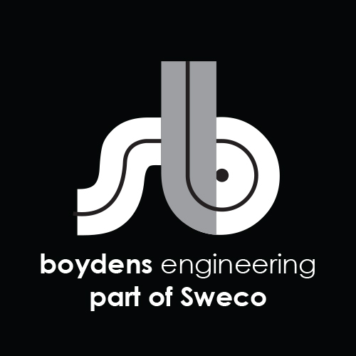

**Job Description:**

|  |  |
| --- | --- |
| Department | Structural Team |
| Position | Structural Engineer |
| Work Location | Dist 1 - HCM/ Hoang Cau – Ha Noi |
| Direct Manager | Team Leader |

Boydens Engineering Vietnam is a branch of, and 100% FDI owned by Boydens sustainable Engineering Group, a multidisciplinary engineering practice founded in 1961 in Belgium and since June 2021 a member of Sweco group, Europe’s leading engineering & architectural consultancy company.

For Industry and Infrastructure projects, please visit our website at <https://www.swecobelgium.be/en/>

For Building sector and local projects, please visit our website at [www.boydensvn.com](https://www.boydens/)

Are you interested in transforming the society of tomorrow? Then Boydens Engineering Vietnam should be your first choice of employer. Together with our clients and the collective knowledge of Sweco’s 18500 motivated engineers and other specialists, we co-create solutions that address urbanization, capture the power of digitalization, and make our societies more sustainable.

At Boydens Engineering Vietnam, you enter a challenging work environment with the opportunity to work on interesting projects.

1. **Job Description and responsibilities**

* Collaborate with team members to launch projects
* Under the support/guidance of assigned senior engineers, Understand project requirements and concepts to develop original design and other principle conceptual drawings as quality and schedule requirement.
* Ensuring that the design are undertaken in accordance with local codes and international standards
* Ensure that all drawings are reviewed and checked before submission by senior engineers or contact window prior to external issued
* Translating functional requirements into technical design (plans, bill of materials, specification, calculation tables
* Taking the best of the provided BIM platform, coordinate with other disciplines in working on 3D designing software in order to design neat and clashing control as requirement.
* Assist in checking related work’s calculation and design drawing/BOQ to ensure quality of the result.
* Additional duties as in Annex 1 (contact-window) in case of responsibility for CW of the assigned projects.
* Other duties upon request

1. **We are looking for:**

* Bachelor degree in structural field
* From 2 years of experience in structural design field
* 2 years working for Boydens engineering is a plus
* Basic knowledge of local codes local codes & standards and/ or knowledge of international (EN) code and standards.
* Good knowledge of Autocad
* Good knowledge of Microsoft Office including words, Excel…
* Good knowledge of REVIT
* Basic knowledge of buildings techniques (structural, detailing of concrete and steel structure and civil...)
* Familiarity with design techniques
* Have knowledge of calculation software such as Sofistik, Etab, Safe.
* Have knowledge of Scia – calculation software is a plus
* Hardworking, eager to learn and attention to details.
* Able to read and understand English.
* Experience on site is a plus
* Knowledge of prefab building techniques is a plus

**ANNEX: ROLE & RESPONSIBILITY _ CONTACT-WINDOW BELGIUM PROJECTS**

* Attend project kick-off meeting with TLs/BE team.
* Communicate with BE designers/BE PLs via email/ Teams meeting… to collect all necessary input information for projects.
* Check projects’ input information, clarify questions with BE designers/ BE PL.
* Arrange/ record input information into project folders in server.
* Explain project design requirement/ input information to VN designers in the team, support VN designers during whole design period of the project.
* Check all drawings/ BOQ/ documents before submitting to BE.
* Perform clashes-control and send the report to VN designers to revise.
* Lead the coordination process with other design discipline.
* Monitor progress and performance of members in assigned projects.
* Follow up spent time and progress of the project. Report abnormalities proactive.
* Accountable for quality of output drawings/ documents.

1. **We offer**

* Opportunity to work on forward thinking projects/overseas projects using the most advanced tools and international standards
* International working environment and European management style
* Competitive salary according to personal experience and ability
* Training opportunities to develop your career
* 15 days annual leave, 12 days sick leave, 15-20 days child sick leave
* International private hospitalization insurance with annual health check at Vinmec (VIP package)
* Social insurance, health insurance, unemployment insurance, trade union paid following labor law
* Team building, year end party activity and other benefits following company policy
* 5 working days per week (Mon to Fri) with flexible starting time (7AM-9AM).

1. **Starting date: ASAP**

Interested candidates should send their detailed CVs in English quoting the reference code above to  [trinhtn@boydensvn.com](mailto:%20trinhtn@boydensvn.com) - Phone/Zalo 0938 308 550

All applications will be kept strictly confidential and only those who are under consideration will be contacted.