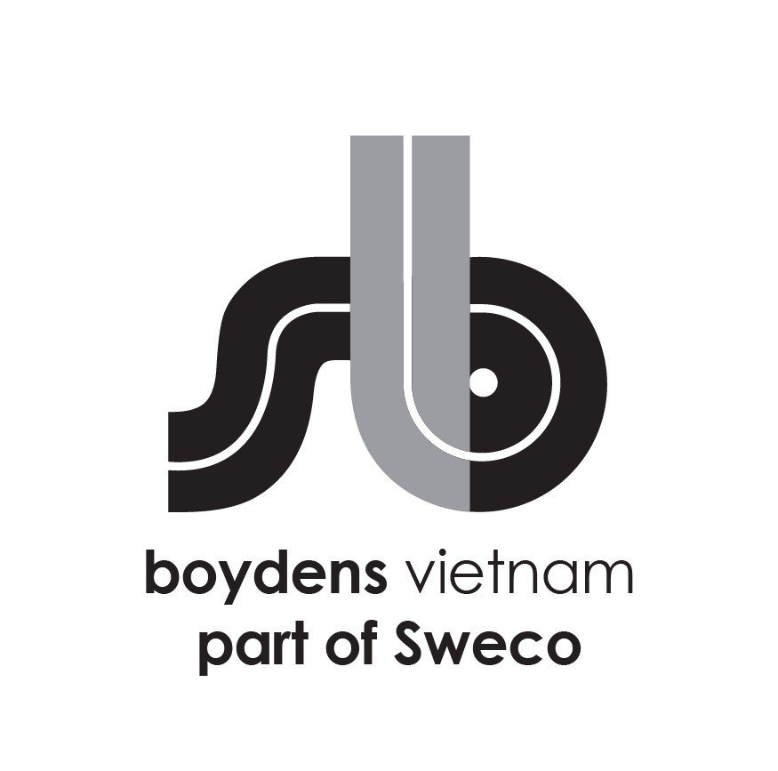

**Job Description:**

|  |  |
| --- | --- |
| Department | HVAC Team |
| Position | Junior – HVAC Engineer (International Projects) |
| Work Location | Dist 1 - HCM/ Hoang Cau – Ha Noi |
| Direct Manager | Team Leader |

Boydens Vietnam part of Sweco (Sweco Vietnam) is a branch of, and 100% FDI owned by Sweco Belgium, a member of Sweco Group, Europe’s leading engineering & architectural consultancy company.

For Industry, Energy and Infrastructure projects, please visit our website at www.swecogroup.com

For Building sector and local projects, please visit our website at [www.boydensvn.com](https://www.boydens/)

At Sweco Vietnam, we are passionate about transforming society and shaping the future. By collaborating with our clients and leveraging the collective knowledge of our team of over 21,000 motivated engineers and specialists, we co-create innovative solutions that address urbanization, harness the potential of digitalization, and foster sustainability in our societies. If you are eager to be part of this transformative journey, Sweco Vietnam is the ideal employer for you.

1. **Job Description and responsibilities**

* **Work** with the dedicated team **on** **international (mostly European) projects** in an efficient and time-conscious manner on **BIM** modeling, preparing the production of drawings, schedules, specification notes, etc. primarily in **REVIT**
* **Collaborate with team members to launch projects.**
* **Understand project requirements and concepts to complete the assigned tasks as quality and schedule requirement (Under the support/guidance of assigned senior engineers)**
* **Ensuring that the assigned tasks are designed in accordance with local codes and international standards (under the support/guidance of assigned senior engineers / leading engineer**)
* **Ensure that all drawings are reviewed and checked before submitting to senior engineers or contact window prior to external issued**
* Maintain high quality of drawings (ensure that all drawings are reviewed and checked before submitting to senior engineers or contact window prior to external issued)
* Translating functional requirements into technical design (plans, bill of materials, calculation tables)
* Under the guidance/ training of assigned senior engineers, working on 3D designing software.
* Coordinate with other designers during design process for clashing control.
* Other duties upon request

1. **We are looking for:**

* Bachelor degree in HVAC field
* 0-2 years of experience in HVAC design field
* Have knowledge of REVIT & BIM
* Basic knowledge of Microsoft Office including words, excel.
* Basic knowledge of HVAC field
* Good knowledge in 3D modeling, drawings documenting
* Hardworking, eager to learn and attention to details
* Able to read and understand English (good communication skills in English is a plus).

1. **We offer**

* Opportunity to work on forward thinking projects/overseas projects using the most advanced tools and international standards
* International working environment and European management style
* Competitive salary according to personal experience and ability
* Training opportunities to develop your career
* 15 days annual leave, 12 days sick leave, 15-20 days child sick leave
* International private hospitalization insurance with annual health check at Vinmec (VIP package)
* Social insurance, health insurance, unemployment insurance, trade union paid following labor law
* Team building, year end party activity and other benefits following company policy
* 5 working days per week (Mon to Fri) with flexible starting time (7AM-9AM).

1. **Starting date: ASAP**

Interested candidates should send their detailed CVs in English to  [trinhtn@boydensvn.com](mailto:%20trinhtn@boydensvn.com) - Phone/Zalo 0938 308 550

All applications will be kept strictly confidential and only those who are under consideration will be contacted.