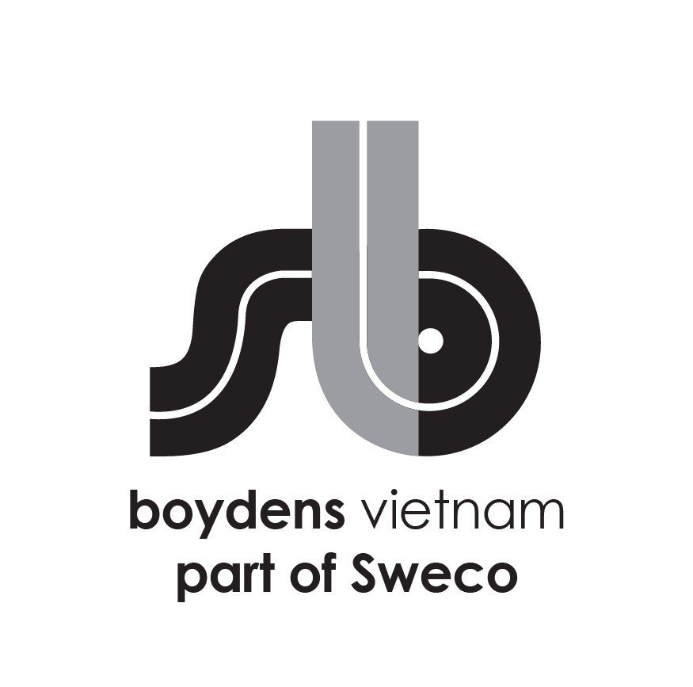

**Job Description:**

|  |  |
| --- | --- |
| Department | Worksharing Department Road & Sewage |
| Position | **Junior designer roads & sewers** |
| Work Location | Dist 1 – HCM / Dong Da – Hanoi |
| Direct Manager | Team Leader/ WorkShare Manager |

Boydens Engineering Vietnam is a branch of, and 100% FDI owned by Boydens sustainable Engineering Group, a multidisciplinary engineering practice founded in 1961 in Belgium and since June 2021 become a member of Sweco group.

For Industry and Infrastructure projects, please visit our website at <https://www.swecobelgium.be/en/>

For Building sector and local projects, please visit our website at [www.boydensvn.com](https://www.boydens/)

Are you interested in transforming the society of tomorrow? Then Boydens Engineering Vietnam should be your first choice of employer. Together with our clients and the collective knowledge of our 18500 motivated engineers and other specialists, we co-create solutions that address urbanization, capture the power of digitalization, and make our societies more sustainable.

At Boydens Engineering Vietnam, you enter a challenging work environment with the opportunity to work on interesting projects.

**For our Workshare Division Roads & Sewage, we are looking for a junior designer roads & sewers to assist in the preparation of projects.**

1. **Job Description and responsibilities**

As part of one of the Workshare Teams in HCMC and in close collaboration with the Team Lead and other members of the project team your work could be included but not limited to:

* You are part of one of the Road & Sewage Workshare Teams.
* You are assisting in the preparation of new or updating of existing projects such as the production of plans (ground plans, sections, details, production of pdf’s …) for the design, permits, As Built files,…
* Implementation of Sweco and client specification & procedures.
* Manage and/or archive files/documents according to internal procedures.
* Other duties as assigned.

1. **We are looking for:**

* Welcome dynamic and motivated fresh graduated Civil engineer or relevant major.
* 1-2 years of experience is a plus.
* Good in English in reading and writing. Good English communication is a plus.
* Sound knowledge of engineering design principles.
* Good knowledge of Civil 3D is a plus
* Good knowledge of Microstation is a plus.
* Eyes for quality and details.
* Good command of MS Office applications.
* Excellent teamwork and communication skills.

1. **We offer**

* Opportunity to work on forward-thinking projects/overseas projects using the most advanced tools and international standards.
* International working environment and European management style.
* Competitive salary according to personal experience and ability.
* Training opportunities to develop your career.
* 15 days annual leave, 12 days sick leave, 15-20 days child sick leave.
* International private hospitalization insurance with an annual health check at Vinmec (VIP package).
* Social insurance, health insurance, unemployment insurance, trade union paid following labor law.
* Team building, year-end party activity and other benefits following company policy.
* 5 working days per week (Mon to Fri) with flexible starting time (7AM-9AM).

1. **Starting date: ASAP**

Interested candidates should send their detailed CVs in English quoting the reference code above to  [trinhtn@boydensvn.com](mailto:%20trinhtn@boydensvn.com) - Phone/Zalo 0938 308 550

All applications will be kept strictly confidential and only those who are under consideration will be contacted.

**PHẠM VI CÔNG VIỆC**

**SCOPE OF WORK**

Là thành viên của Nhóm workshare tại TP HCM và phối hợp chặt chẽ với Trưởng nhóm cùng các thành viên khác của nhóm dự án, công việc của bạn bao gồm (nhưng không giới hạn):

As part of one of the Workshare Teams in HCMC and in close collaboration with the Team Lead and other members of the project team your work could be included but not limited to:

* Bạn là thành viên của Nhóm Workshare Hạ Tầng Kĩ thuật.

*You are part of one of the Road & Sewage Workshare Teams.*

* Bạn sẽ hỗ trợ làm các bản vẽ của dự án mới, hoặc cập nhật các bản vẽ của các dự án cũ như là (bản vẽ mặt bằng,mặt cắt (cắt dọc, cắt ngang), chi tiết kết cấu ... bằng tệp PDF) cho các bước thiết kế, xin phép xây dựng, bản vẽ hoàn công.

*You are assisting in the preparation of new or updating of existing projects such as the production of plans (ground plans, sections, details, production of pdf’s …) for the design, permits, As Built files,…*

* Tuân thủ quy trình và yêu cầu kĩ thuật của khách hàng và Sweco.

*Implementation of Sweco and client specification & procedures.*

* Quản lý và/ hoặc lưu trữ các tệp/ tài liệu theo quy trình nội bộ.

*Manage and/or archive files/documents according to internal procedures.*

* Các nhiệm vụ khác được phân công.

*Other duties as assigned.*

**YÊU CẦU**

**REQUIREMENTS**

* Sinh viên năm cuối năng động và cầu tiến tốt nghiệp ngành Kĩ thuật Xây Dựng, hoặc các ngành liên quan.

*Dynamic and motivated fresh graduated Civil engineer or relevant major.*

* Ưu tiên các bạn có 1-2 năm kinh nghiệm.

*1-2 years of experience is a plus.*

* Có khả năng đọc hiểu và viết bằng tiếng Anh tốt. Ưu tiên các bạn có khả năng giao tiếp tiếng Anh tốt.

*Good in English in reading and writing. Good English communication is a plus.*

* Hiểu về quy trình thiết kế kỹ thuật.

*Knowledge of engineering design principles.*

* Có kiến thức về Civil 3D là một lợi thế

*Good knowledge of Civil 3D is a plus*

* Thành thạo Microstation là một lợi thế.

*Good knowledge of Microstation is a plus.*

* Chú trọng chất lượng và chi tiết.

*Eyes for quality and details.*

* Ứng dụng MS Office tốt.

*Good knowledge of MS Office.*

* Khả năng làm việc nhóm và giao tiếp tốt.

*Excellent teamwork and communication skills.*