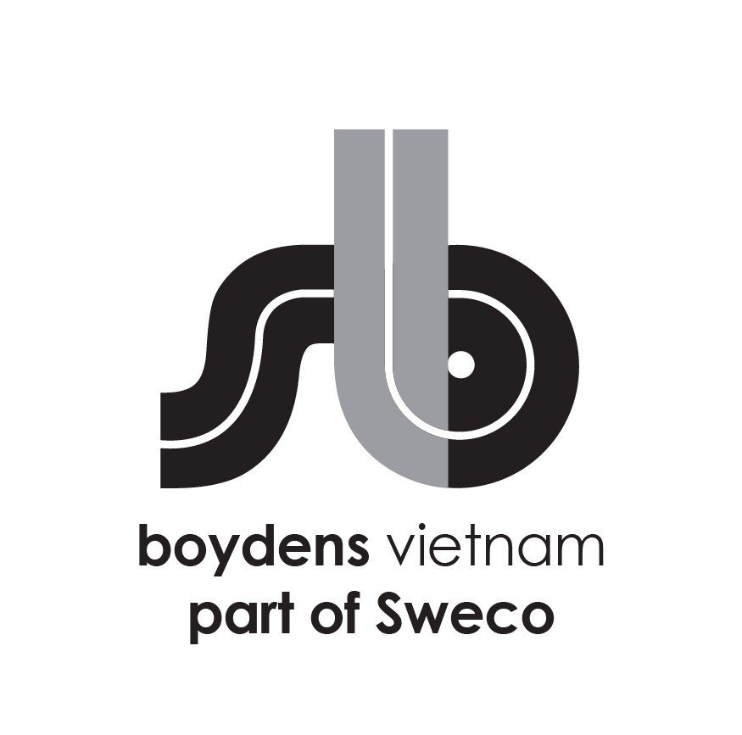

**Job Description:**

|  |  |
| --- | --- |
| Department | Infrastructure |
| Position | **Designer Urban Roads & Sewers** |
| Work Location | Hanoi |
| Direct Manager | Team Leader/ WorkShare Manager |

Boydens Engineering Vietnam is a branch of, and 100% FDI owned by Boydens sustainable Engineering Group, a multidisciplinary engineering practice founded in 1961 in Belgium and since June 2021 a member of Sweco group, Europe’s leading engineering & architectural consultancy company.

For Industry and Infrastructure projects, please visit our website at <https://www.swecobelgium.be/en/>

For Building sector and local projects, please visit our website at [www.boydensvn.com](https://www.boydens/)

Are you interested in transforming the society of tomorrow? Then Boydens Engineering Vietnam should be your first choice of employer. Together with our clients and the collective knowledge of Sweco’s 18500 motivated engineers and other specialists, we co-create solutions that address urbanization, capture the power of digitalization, and make our societies more sustainable.

At Boydens Engineering Vietnam, you enter a challenging work environment with the opportunity to work on interesting projects.

**For our division Infrastructure we are looking for a Designer Roads & Sewers to assist in the preparation of Urban Roads & Sewer projects.**

1. **Job Description and responsibilities**

As part of one of the Workshare Teams and in close collaboration with the Team Lead and other members of the project team your work could be but not limited to:

* Assisting with the conceptual & detailed design of urban roads, squares, …. preparing the ground plans, long- and cross sections, etc
* Assisting in the conceptual & detailed design of the sewer system (stormwater management and sewage) and related constructions such as overflows, special constructions, storm water storage, pump stations, including the necessary drawings
* Preparing and production of the required details
* Prepare drawing to submit for the Building Permit.
* Calculation of quantities for estimations and Tender documents.
* Creation of As Built files
* Implementation of Sweco and client specification & procedures.
* You work independently on the assignments with the relevant software tools AutoCAD and/or Autodesk Civil3D
* Manage and/or archive files/documents according to internal procedures

1. **We are looking for:**

* Good in English speaking and writing. Knowledge of French language is a plus.
* Dynamic and motivated designer with 2 – 3 years of experience
* Sound knowledge of engineering design principles
* Good knowledge of Civil3D and use of Revit and/or Microstation is a plus
* Eyes for quality and details
* Good command of MS Office applications.
* Excellent teamwork and communication skills
* Self-starter who can work independently and with team members
* Willing to travel to Belgium for training or projects if needed.

1. **We offer**

* Opportunity to work on forward thinking projects/overseas projects using the most advanced tools and international standards
* International working environment and European management style
* Competitive salary according to personal experience and ability
* Training opportunities to develop your career
* 15 days annual leave, 12 days sick leave, 15-20 days child sick leave
* International private hospitalization insurance with annual health check at Vinmec (VIP package)
* Social insurance, health insurance, unemployment insurance, trade union paid following labor law
* Team building, year end party activity and other benefits following company policy
* 5 working days per week (Mon to Fri) with flexible starting time (7AM-9AM).

1. **Starting date: ASAP**

Interested candidates should send their detailed CVs in English quoting the reference code above to  [trinhtn@boydensvn.com](mailto:%20trinhtn@boydensvn.com) - Phone/Zalo 0938 308 550

All applications will be kept strictly confidential and only those who are under consideration will be contacted.

**PHẠM VI CÔNG VIỆC**

**SCOPE OF WORK**

Là thành viên của nhóm Workshare và hợp tác chặt chẽ cùng trưởng nhóm và các kỹ sư khác của dự án với phạm vi công việc như dưới đây nhưng không giới hạn như sau; *As part of one of the Workshare Teams and in close collaboration with the Team Leader and other members of the project team the scope of work could be but not limited to:*

* Hỗ trợ thiết kế ý tưởng và thiết kế chi tiết các tuyến đường đô thị, quảng trường,…. Chuẩn bị bản vẽ bình đồ tuyến, mặt cắt dọc, ngang và chi tiết … *Assisting with the conceptual & detailed design of urban roads, squares, …. preparing  
  the ground plans, long- and cross sections, details,…etc*
* Hỗ trợ thiết kế ý tưởng & chi tiết hệ thống nước thải (quản lý nước mưa và nước thải) và các công trình liên quan như tràn, công trình đặc biệt, bể chứa nước mưa, trạm bơm, bao gồm các bản vẽ cần thiết *Assisting in the conceptual & detailed design of the sewer system (stormwater management and sewage) and related constructions such as overflows, special constructions, storm water storage, pump stations, including the necessary drawings*
* Chuẩn bị và thực hiện các bản vẽ chi tiết theo yêu cầu

*Preparing and production of the required details*

* Chuẩn bị bản vẽ xin Giấy Phép Xây Dựng

*Prepare drawing to submit for the Building Permit*

* Tính toán khối lượng để lập dự toán và tài liệu đấu thầu *Calculation of quantities for estimations and Tender documents.*
* Tạo file bản vẽ hoàn công

*Creation of As Built files*

* Thực hiện các chỉ dẫn kỹ thuật và quy trình của Sweco và khách hàng*.*

*Implementation of Sweco and client specification & procedures*

* Chủ động thực hiện công việc được giao với các công cụ phần mềm sau nhưng không giới hạn như Auto CAD và Autodesk Civil 3D

*You work independently on the assignments with the relevant software tools such as but not limited to AutoCAD and Autodesk Civil3D*

* Quản lý và/hoặc lưu files/tài liệu theo đúng quy trình nội bộ *Manage and/or archive files/documents according to internal procedures*
* Hoàn thành các nhiệm vụ khác được giao

*Other duties upon request*